The Art of Science:
How Leonardo Da Vinci Shaped the Modern World

Maddy Park

Madeline Abigail Park
Miss Thompson, Mr. Johnson
Modern World History, English II
November 3, 2013

Several centuries ago, there lived a man of both science and art, and of both creativity and mind: a true Renaissance man. His name is one that is known all over the modern world; he is Leonardo Da Vinci. For Leonardo, there was no divide between art and science; merely art and science were one, consolidated together to create some of the most celebrated works of all time. Leonardo saw things in a different light and pursued what was deemed to be impossible. This made him one of the most influential people of both the 15th century and today. Even to this day, Da Vinci’s paintings, techniques, studies, and inventions have influenced the spheres of art, medicine, and science. If Leonardo Da Vinci had never existed, it would be a different world today.
For most, upon hearing the name Leonardo Da Vinci, the first thing that comes to mind is his painting, the Mona Lisa. Even children are aware of the Mona Lisa from a young age. It is arguably the most famous painting in the world. But why is this? What makes the Mona Lisa so special that even those who do not know a thing about art, know this painting? The Mona Lisa is a representation of Da Vinci’s passion for art, his new discoveries, and willingness to try things new. When looking at the Mona Lisa, an immense part of its popularity came from the fact that the painting seemed to break every aspect of traditional painting, yet still uphold Renaissance techniques and values. Leonardo first started to stray from the cliché techniques of Renaissance paintings by using a different type of canvas; this canvas was called cottonwood paneling, and it was what caused the longevity of the Mona Lisa. Another way that the Mona Lisa broke tradition was through the pose of the lady in the painting. She was painted from the waist up, with her hands sitting neatly on her lap. This differed from previous paintings, which depicted people in full length. Leonardo not only changed small details of the painting, but he also introduced new painting techniques. Usually, people would paint both the background and the front of the painting with the same amount of detail. However Leonardo used a technique called sfumato, which meant that he blurred the edges and the background to form a more realistic painting. This technique is also used on Mona Lisa’s face. Another technique he used is called chiaroscuro. This was created by Da Vinci himself. It is done by using light and dark colors to add contrast to the painting. It draws out certain elements in the painting yet add subtle realism. (Mona Lisa by Leonardo Da Vinci) It is a symbol of art itself. (Why is the Mona Lisa so Famous?). Symbols themselves are highly influential and powerful. Just by looking at a symbol, we can figure out the associations and meanings that are behind it. (The Importance of Symbols) The Mona Lisa tells a story without using words. It symbolizes all of Da Vinci’s art and the revolution that he brought about through it. It symbolizes a change in styles and the development of the arts in general. It symbolizes timeless works of art that still remain treasures and pieces of history that have maintained themselves through the harsh winds of time.
A lesser known aspect of the world that Da Vinci contributed to greatly was the medical world. One specific area that he focused on was the human anatomy. During his lifetime, Leonardo dissected at least 30 corpses—both diseased and healthy—as to get a full understanding of the human body. Several people such as Plato and Aristotle had studied the topic beforehand, yet Da Vinci was among the first to provide both accurate drawings and explanations of the anatomy. This is evident from Leonardo’s sketch of the Vitruvian Man. The Vitruvian Man is a drawing of a man who is standing in the middle of a circle and a square. This man is depicted in two different poses, which gives an exact representation of the proportions of the human body. (Andrei, 5 Things Leonardo Da Vinci did to Change the World) The Vitruvian Man is but a page in notebooks that were full of information about the human body. Da Vinci intended for these notebooks to be used in the medical field. (Sexton, Leonardo Da Vinci and the Study of the Human Anatomy) However, these books didn’t take its desirable impact until the 1900s, when two of Leonardo’s notebooks were rediscovered in 1965. In it lay many of Leonardo’s sketches, even some about robots that he wanted to create. One of the most famous robots found in the notebooks is called Leonardo’s Robot. (Leonardo Da Vinci: The Engineer) It was designed as a suit of armor that could stand, sit, wave its arms, and raise its visor through a series of pulleys and mechanics. (Leonardo Da Vinci’s Robot) In 2002, Mark Rosheim built a prototype of Leonardo’s Robot called the Robotic Knight. His prototype was successful, showing us that Leonardo had a full understanding of how the human body and joints worked in order to design the robot. Leonardo’s Robot and his accurate sketches of the human anatomy inspired scientists today to create a surgical robot. The surgical robot was named after Da Vinci and is used today to perform many surgeries such as heart surgery, prostate surgery, hysterectomies, and joint-replacements. (Leonardo Da Vinci: The Engineer) This is beneficial to us because it has shown to increase the surgical precision of a doctor, minimize incision size, lessen the risk of transfusion, shorten recovery time, and provide a better environment for doctors by reducing strain and fatigue. (All About Robotic Surgery, and Jacobs, Da Vinci’s Robot) However, not only did Da Vinci impact the surgical side of the medical world, but he also contributed to the development of artificial limbs and synthetic organs. His studies on how limbs and organs work have influenced scientists today to create “replacements” of body parts in order for people to function normally. (Sexton, Leonardo Da Vinci and) Leonardo Da Vinci’s contributions to science and medicine has not only improved the quality of life but has advanced techniques in each of these spheres.
Many people view Da Vinci as just an artist, but not many know that he was also an inventor and engineer. He was fascinated by the things of the world. This fascination probably propelled him to design many new inventions that were beyond his time. One of his most famous inventions is the mobile bridge, which was invented to transport soldiers. This bridge is mobile which means that they would be able to carry it with them to different places. However, this bridge is not really used today, rather, instead, Da Vinci’s concept of using curved wooden slats on bridges is used. This is not only used on bridges, but also other arches that are made of wood. Leonardo was also credited with the invention of the gated canal. The canal later became crucial for importing and exporting goods into other countries. (Canals 1750 to) Da Vinci was also interested in flying machines. He was the first to come up with the concept of the parachute and the helicopter. Though, sadly, both were not created at the time since the technology in the 1500s was too primitive for Da Vinci’s ideas. His ideas have greatly influenced the world.
Though Da Vinci lived several centuries ago, his legacy still lives on today. This is evident through his many inventions, paintings, and studies that he has left behind that have impacted the world greatly. Without Da Vinci, there would be many medical issues with people with lost limbs, art that is more primitive and lower standards of technology. Through Leonardo Da Vinci’s legacy, the Renaissance lives on in the modern age.

Works Cited
"All About Robotic Surgery." Surgical Robots, Robotic Surgery, Robotic Systems. N.p., n.d.
Web. 02 Nov. 2013.

Andrei, Mihai. "5 Things Leonardo Da Vinci Did to Change the World." ZME Science. N.p., 19
May 2008. Web. 02 Nov. 2013.

"Canals 1750 to 1900." Canals 1750 to 1900. N.p., n.d. Web. 03 Nov. 2013.

"History of Contact Lenses." Lensprices.co.uk. N.p., n.d. Web. 02 Nov. 2013.

"Illumin - Leonardo Da Vinci: The Engineer." Illumin - Leonardo Da Vinci: The Engineer.
University of California, n.d. Web. 02 Nov. 2013.

Jacobs, Katie. "Da Vinci's Robot: Surgery Is Getting a Renaissance." Penn State News.
Pennsylvania State University, 24 Apr. 2013. Web. 2 Nov. 2013.

"Leonardo Da Vinci Biography." Bio.com. A&E Networks Television, n.d. Web. 07 Oct. 2013.

"Leonardo Da Vinci's Life." The Impact of Leonardo Da Vinci Paintings. N.p., n.d. Web. 07 Oct.
2013.

"Leonardo Da Vinci's Robots." Leonardo Da Vinci's Robots. N.p., n.d. Web. 02 Nov. 2013.

"Mona Lisa by Leonardo Da Vinci – Facts & History of the Painting." Totally History Mona
Lisa Comments. N.p., n.d. Web. 07 Oct. 2013.

Murtaugh, Leallyn. "Illumin - Leonardo Da Vinci: The Engineer." Illumin - Leonardo Da Vinci:
The Engineer. N.p., n.d. Web. 03 Nov. 2013.

Sexton, Timothy. "Leonardo Da Vinci and the Study of the Human Anatomy." Yahoo Contributor Network. Yahoo, 6 Jan. 2007. Web. 02 Nov. 2013.

"The Importance of Symbols." Government of Newfoundland and Labrador. N.p., n.d. Web. 02
Nov. 2013.

The Vitruvian Man. N.p., n.d. Web. 07 Oct. 2013.

"Why Is the Mona Lisa so Famous?" The Straight Dope:. N.p., n.d. Web. 07 Oct. 2013.

Primary Sources:
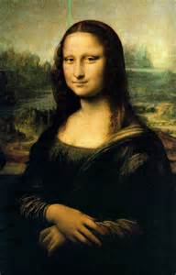 <The Mona Lisa>

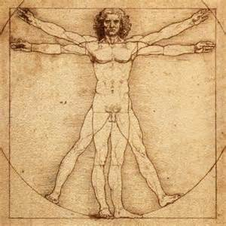 <The Vitruvian Man>

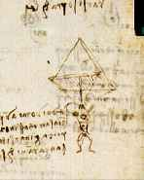 <Da Vinci’s Parachute>
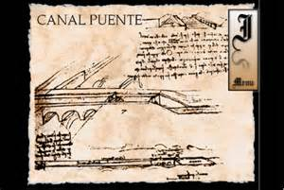 <Da Vinci’s Canal>
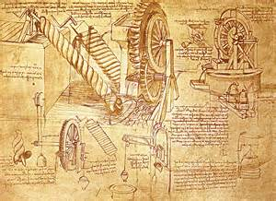 <Da Vinci’s Codex>

